„Alexandru Ioan Cuza” University of Iasi

Faculty of Economics and Business Administration

Master Software Development and Business Information Systems

**MANAGEMENT SYSTEM FOR RESEARCH PUBLISHING**

**FOR THE ROMANIAN FOUNDATION FOR BUSINESS INTELLIGENCE**

Scientific coordinator,

Professor Florin Dumitriu

Students,

Ignea Vlad

Nistor Carmen

Iasi, 2015

**TABLE OF CONTENTS**

Chapter I. Short description of functional characteristics of the application 3

1.1. Module articles 3

1.2. Module editorial team 4

1.3. Module receipts 4

1.4. Module payments 4

1.5. Module Journals 5

1.6. Module Conferences 5

Chapter II. Structuring the functional requirements of the application 6

2.1. Activity diagram for describing the application 6

2.2. Use Case Diagrams 8

2.3. Narrative description of use cases 11

2.4. Use case description with diagrams of activities 11

Chapter III. Presentation of the application architecture 15

Chapter IV. Descriptions of interactions between classes 18

Chapter V. Description of the objects behavior of a class 19

# Chapter I. Short description of functional characteristics of the application

Within the application, the editor in chief, the editors and the assistant editors will be able to assess the articles send by the authors and the related tasks of every member of the editorial board. The application will be composed by the following four modules: **Articles**, **editorial team**, **payments** and **receipts**.

## 1.1. Module articles

In this module, the editorial team will have an evidence of all the articles send by the authors in order to be published in the journals of the foundation or in order to participate at the conferences organized by the foundation and then to be published in one of the journals.

In this module, the articles will be added by authors. The approval and the acceptance decision is the responsibility of the editorial team which can view and request the modification of the articles according to the foundation requirements. In order to be published in one of the journals of the foundation every articles is paid by the authors. If an author has published several articles in foundation journals he / she can receive a discount in the future for publishing his work in one of the journals.

The main operations identified in this module can be resumed to:

* **Add new article**, when adding a new article the editor will complete the following: the title of the article, data identification for the author, type of article, the submission date, the estimated date of final review, the reviewers involved, and the state in which the article is to be found “1st screening”;
* **Modify article** - during the acceptance to be publish in one of the journals issued by the foundation and / or in order to participate in one of the conference organized by the foundation, each article published by an author is reviewed by several reviewers. The editor in chief can modify the article, giving the final acceptance or rejection;
* **Delete article** – if an article is rejected because doesn’t fulfill the foundation requirement concerning the content, the form or is plagiarized the article will be deleted;
* **Visualize article** – it returns general information regarding an article (its name, type, research field, name of the author, the date when it was received, the review process (is still in review, the article was accepted, the article was rejected).

## 1.2. Module editorial team

In this module, the editor in chief will have an evidence of all the members of the editorial team. The main operations identified are:

* **Add new member team** – adds specific information regarding a new member of the editorial team, namely: name, affiliation (university, faculty, research institute etc.), professional title (professor, lecturer, assistant professor), scientific area of interest, phone number, email and address, position occupied within the editorial team (reviewer, member of the editorial board, language advisor, assistant editor etc.);
* **Modify member** – updates information regarding the existent members of the editorial team;
* **Delete member**;
* **Visualize member** – allows obtaining data regarding the existent authors from the SEA research community.

## 1.3. Module receipts

* **Add new receipt** – adds specific information regarding a new receipt made by authors, namely: name of the author, amount paid, observation (which is the destination of the receipt – publishing within one of the journals or participating in one of the conference;
* **Modify receipt** – updates information regarding the receipts made by authors;
* **Select receipt** – allows the selection of the payment you want to visualize;
* **Visualize receipt** – allows obtaining data regarding the receipts of an author.

## 1.4. Module payments

* **Add new payment** – adds specific information regarding a new payment made by the foundation to international data bases or other specific expenses, namely: name of the partner, bank account, amount paid, observation (which is the destination of the payment – publishing a journal in a specific database, amounts paid for publishing houses, sums paid to the authors etc);
* **Modify payment** – updates information regarding the payments made by the foundation;
* **Select payment** – allows the selection of the payment you want to visualize;
* **Visualize payment** – allows obtaining data regarding the payments made by the foundation.

## 1.5. Module journals

* **Add journal** – adds specific information regarding a new journal published by the foundation, like: name, ISSN (online and physical), issuer, number, volume, year, name of the articles and correspondent authors;
* **Add issue** – adds a new issue to existent journal, namely: year of publication, volume, issue, name, ISSN (online and physical), name of the articles and correspondent authors;
* **Send issue to indexation** – sends a new issue of the journals to international data bases in order to be indexed;
* **Update issue** – modifies an existent issue before indexation;
* **Visualize issue/ journal** – allows the visualization of an issue / a journal published or in publication process by the editor-in-chief.

## 1.6. Module conferences

* **Add new conference** – adds details referring to a new conference organized by the foundation, like: name, the place where is going to be held, the topics of the conference, the period of time, the fees that authors should pay if they want to participate, additional information for participants (sightseeing, places to stay, contact information of the foundation and partners of the conference etc.);
* **Add new institutional partner** – adds details regarding the institutional partners which are in the organizing committee together with the foundation members, namely: the name of the partner, the address, the degree of involvement, contact details etc.;
* **Update conference** – modifies the details of an existent conference, either regarding specific details of the event or the institutional partner;
* **Visualize conference** – allows visualization details of the conference in order to modify them or make decision.

# Chapter II. Structuring the functional requirements of the application

## 2.1. Activity diagram for describing the application

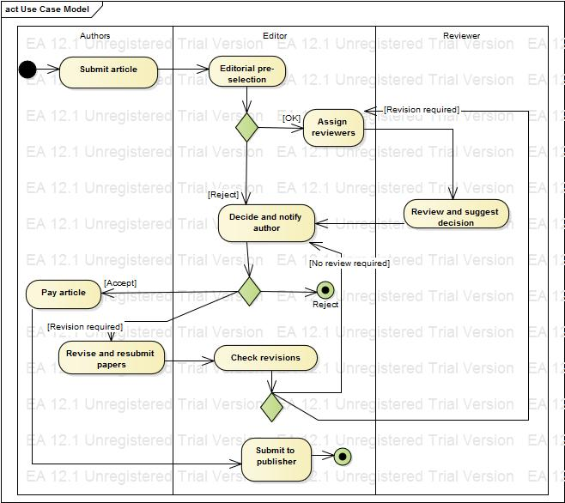

A simplified view of important stages and roles in the publishing process of journal papers is given in the activity diagram. The vertical swim lanes separate the areas of responsibility of the main actors in the process. For simplicity all editorial roles are subsumed under one swim lane.

The first step is to be taken by the author. After choosing an appropriate journal for submission, the author has to submit the paper according to the instructions issued by the journal editor. The application offer the opportunity to submit the paper via the journal’s web. At this stage, it is very important that the author follows the instructions, because submitted papers that do not adhere to (parts of) the instructions can be rejected without taking into account the paper’s actual content.

Some common authors’ mistakes at this stage include:

− not adhering to the journal’s paper formatting and layout guidelines (e.g. using the wrong font size, line spacing, page numbering, referencing style, figure and table placement and visual guidelines);

− exceeding maximum paper length (word count, page count);

− the paper’s thematic focus not being within the scope of the journal’s subject areas.

If any of the above is evident when the editor does the preliminary review, the paper is likely to be immediately rejected regardless of its scientific contribution and quality. On the other hand, if these conditions are met (‘proper paper on a proper subject’), the paper will be considered for publication. The submitting author is notified of either one of these decisions.

The next step the editor takes is to select reviewers for peer reviewing the paper. The number of reviewers involved in the review process consists of two reviewers who are experts in the topic that is covered by the paper. When the assigned reviewers have finished reviewing and commenting the paper, the editor collects their recommendations and makes a decision which is sent to the corresponding author, who is indicated in the submitted manuscript. Generally, the notification by the editor will carry one of the following messages:

*Accept*. The paper is accepted as it was submitted. The paper will be published in one of the journal’s forthcoming issues.

*Revision*. The editor requests a revision of (certain parts of) the paper. The authors have to modify the paper according to the suggestions and comments of the reviewers and the editor in order to be further considered for publication. After revising the paper accordingly, the author may submit the revised manuscript to the editor. This typically requires the authors to enclose a letter to the editor where they outline in detail how the reviewer and editorial comments were addressed in the revised version. After receiving the revised version, the editor either makes an accept/reject recommendation or, if required, forwards the paper for another round of reviewing, which usually involves those reviewers who were most critical about the original submission.

*Reject*. The editor does not see any chance for the paper to be published in the journal. This is the most frequent outcome of the review process of a journal. The editor usually encloses the reviewer comments. Typically, one or more reviewers

• had serious objections to one of the preconditions relevant to reviewers mentioned above;

• found the paper to be out of the journal’s scope, lacking relevance or significance;

•found fundamental flaws in the paper’s argument, data or methodology;

• did not see any improvement with regard to previous submissions of the same paper.

If a revision is required and the author feels unable to comply with the editor’s recommendations, the author may either inform the editor about the disagreement or, alternatively, the paper may be sent to another appropriate journal in the field. The same applies to rejected papers.

## 2.2. Use Case Diagrams

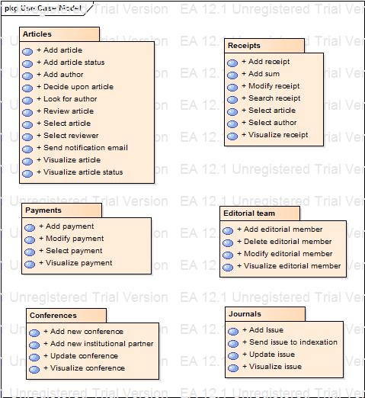

Package diagram

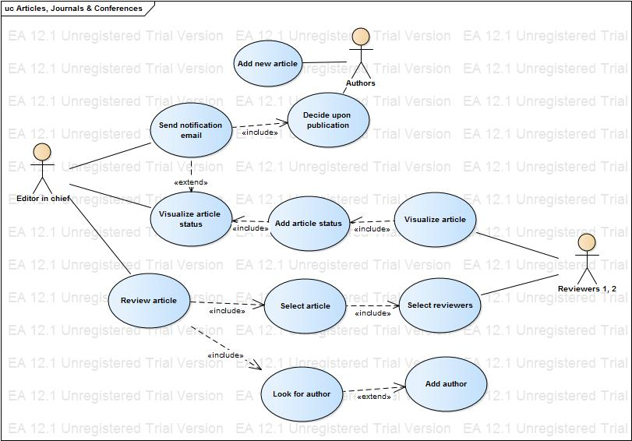

*Use case model for module “articles”*

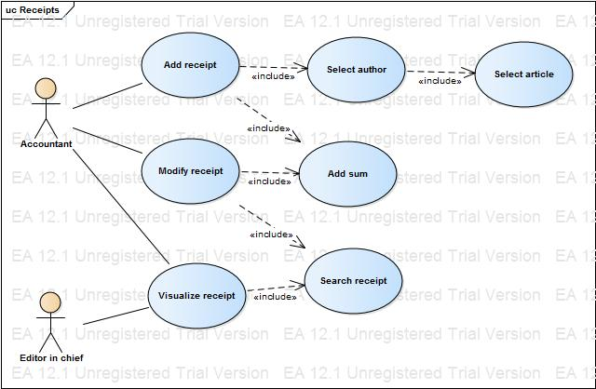

*Use case model for module “receipts”*

## 2.3. Narrative description of use cases

**1st Use case description “Select reviewer”**

Name of Use Case: Select reviewer

Objective: Selecting successfully a reviewer in order to verify a new article

Author: Carmen

Actors: Editor in chief

Priority: 1

Preconditions: The user has to be connected with an account which gives him editor in chief rights / privileges

Post-conditions: 1. Successful finalization. The user has selected the reviewer for the article

Alternative scenarios: 1. Assign the article to a new reviewer

Exceptional scenarios: No

Stages of main scenario:

1. The user views the article;

2. When viewing the article, the user selects the article domain;

3. According to the article domain he assigns the most appropriate reviewers for the interest field;

4. The user sends a notification to review.

Alternative scenario

If at stage 3 from the main scenario the user doesn’t find reviewers for the article domain, then:

1. He goes back at stage 2 and selects the domain as “general”.

2. The use case continues with stage 4.

2nd Use Case Description “send notification email”

Name of Use Case: Send notification email

Objective: Sending successfully a notification email to the author

Author: Carmen

Actors: Editor in chief

Priority: 1

Preconditions: The user has to be connected with an account which gives him editor in chief rights / privileges

Post-conditions: 1. Successful finalization. The user has sends the notification email to the author with payment details.

Alternative scenarios: 1. Send notification email to the author with additional requirements to review

Exceptional scenarios: No

Stages of main scenario:

1. The user selects the article;

2. The user views the article status;

3. When viewing the article status, depending on its value, the user considers that the article needs no improvement or changes;

4. The user decides to notify the author about payment details of the article approved;

5. The user selects the author;

6. The user selects the email of the author;

7. The user sends the email to the author.

Alternative scenario

If at stage 3 from the main scenario the user sees that according to the article status, the article needs improvements, than:

1. He decides to notify the author about modification that has to be made;

2. The use case continues with stage 5.

## 2.4. Use case description with diagrams of activities

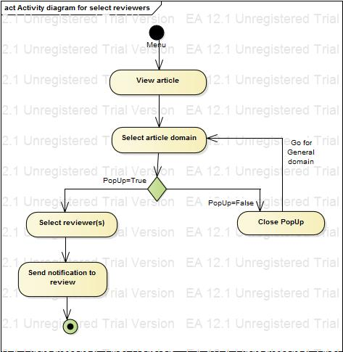

Activity diagram for use case “Select reviewer”

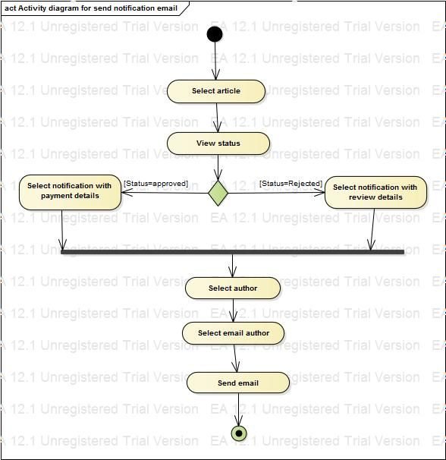

Activity diagram for use case “send notification email”

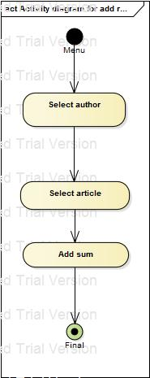

Activity diagram for “add receipt”

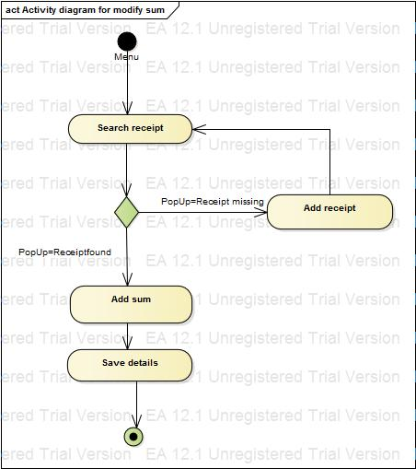

Activity diagram for “modify sum”

# Chapter III. Presentation of the application architecture

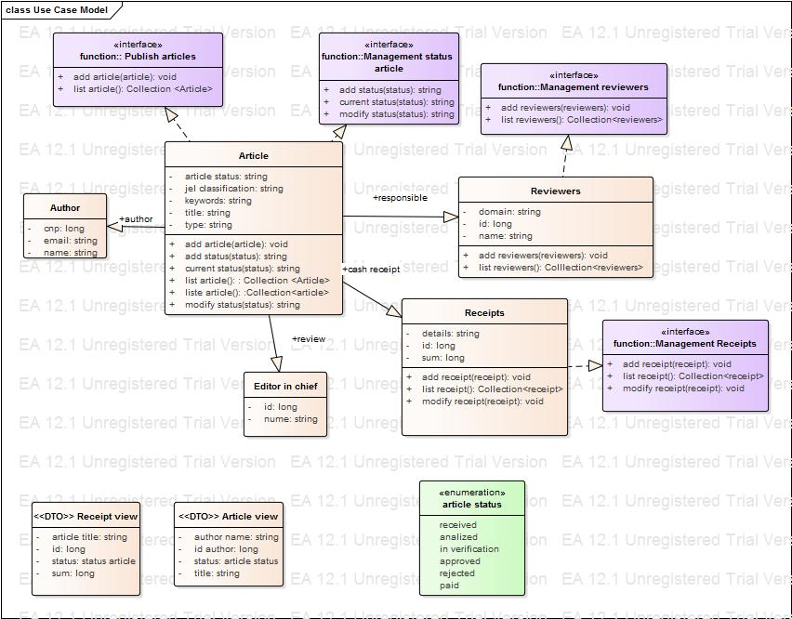

*Class diagram for domain model – structure*

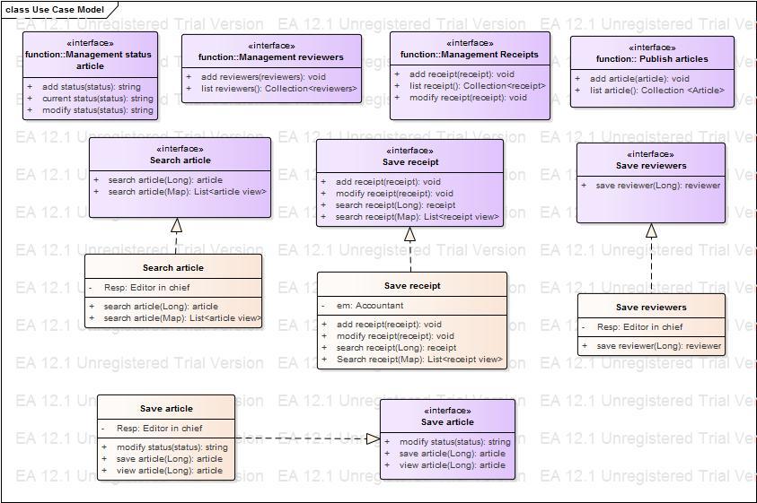

Class diagram for domain model – functionality

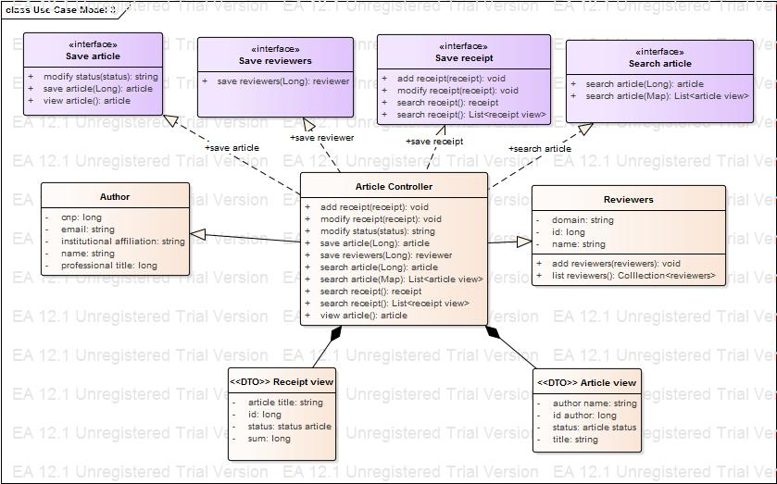

Class model for domain model – controller

# Chapter IV. Descriptions of interactions between classes

# Chapter V. Description of the objects behavior of a class

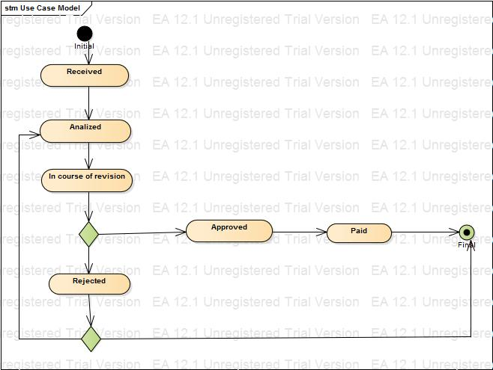

State diagram for object “article”

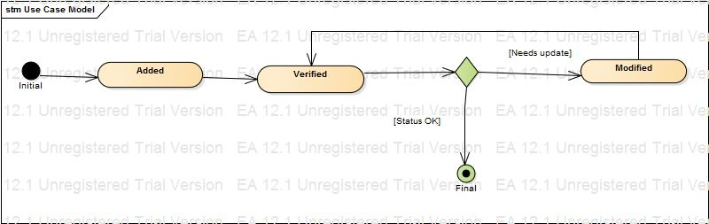

State diagram for object “receipt”